C Language

**-What is Dev C++ & Download, install Dev C++**

-Dev-C++ is a free full-featured integrated development environment (IDE) for programming in C and C++.

**-What is Syntax**

Syntax is a set of rules that defines the structure of a language.

**-What is Compiler**

Compilers convert programming languages like Java or C++ into binary code that computers can understand. If the syntax is incorrect, the code will not compile.

Interpreters execute programming languages such as JavaScript or Python at runtime. The incorrect syntax will cause the code to fail.

-Demonstrate first program to print message and to show comments and basic errors.

-Compile the program n executable file.

**Compilation**

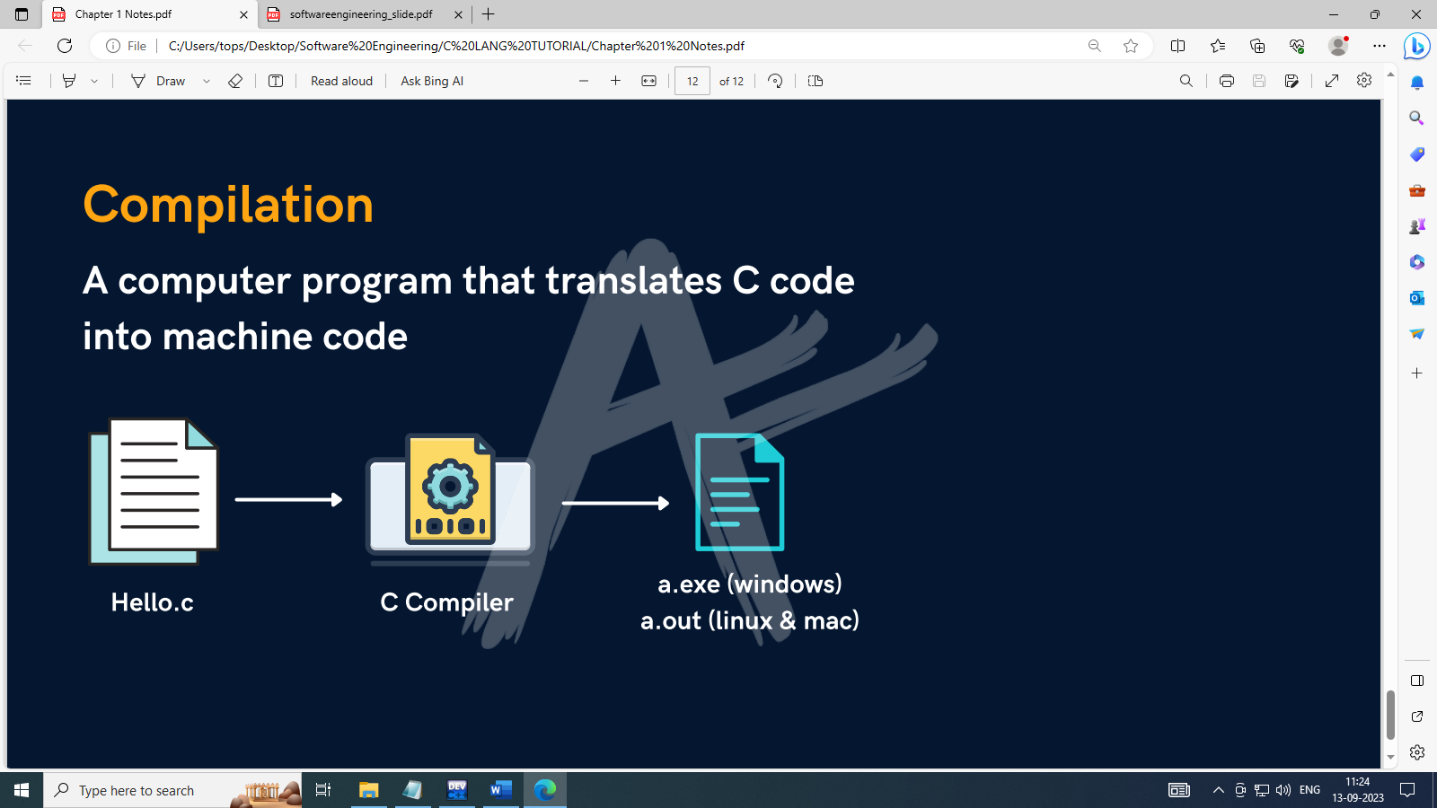

**-What is Comment in Program**

Lines that are not part of the program. E.g program definition

|  |  |
| --- | --- |
| **Single Line** | **//** |
| **Multiple Lines** | **/\***  **\*/** |

-

**-Output in C**

printf(“ Hello C”);

printf(“ \n Hello C”); \n for new line.

printf(“ \t Hello C”); \t for tab space.

**Input in C**

scanf(“%d”, &age); // age is an integer type of variable.

**-What is Variable & Rules for the Variable**

Variable is the name of a memory location which stores some data.

c

b

a

C

3.14

25

* **Rules :**
* Variables are case sensitive.
* 1st character is alphabet or '_'.
* no comma/blank space
* No other symbol other than '_'.

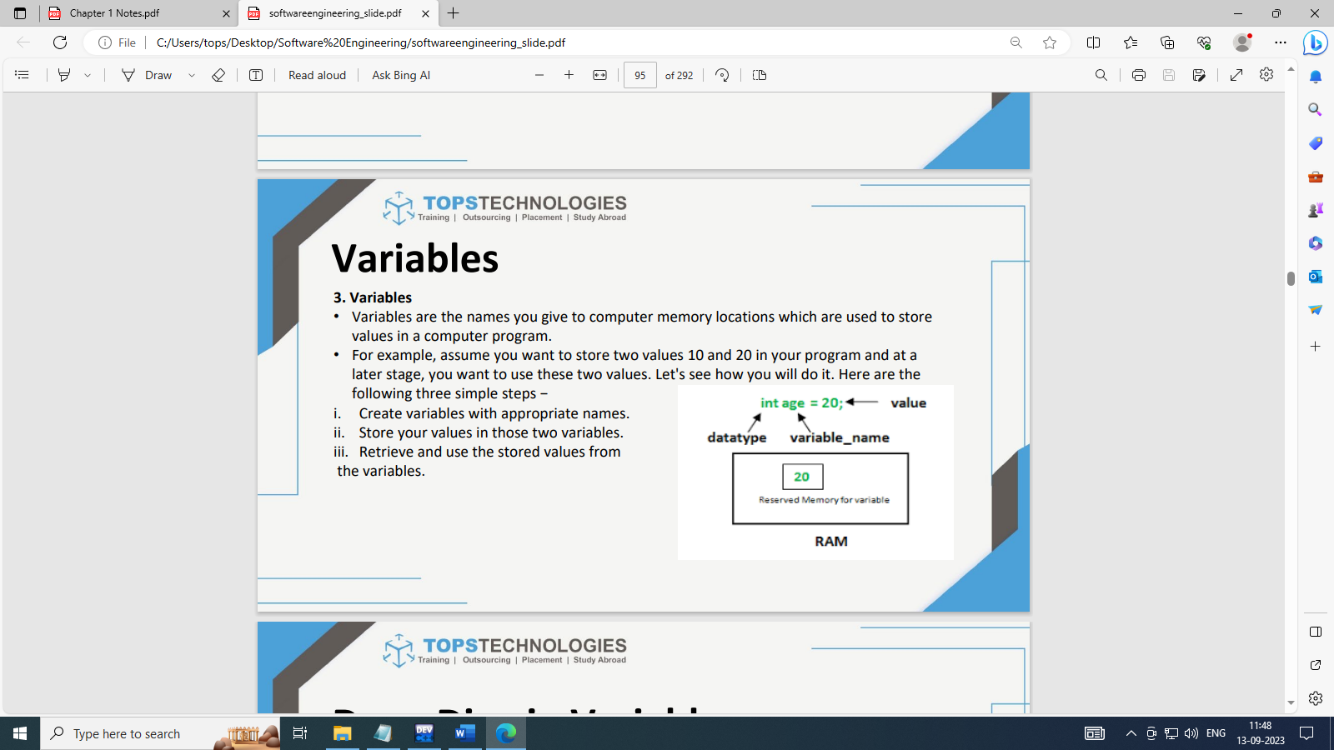

-Demonstrate the prog for user input and print the values.

-Demonstrate datatypes: int, float, long int, double, char.

**-What is Data Structure & What is Data type**

**A data structure** is a particular way of organizing data in a computer so that it can be used effectively.

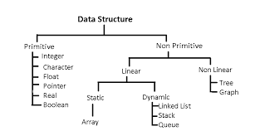

**Data type :** A type of data that a variable can store like int, float, char.

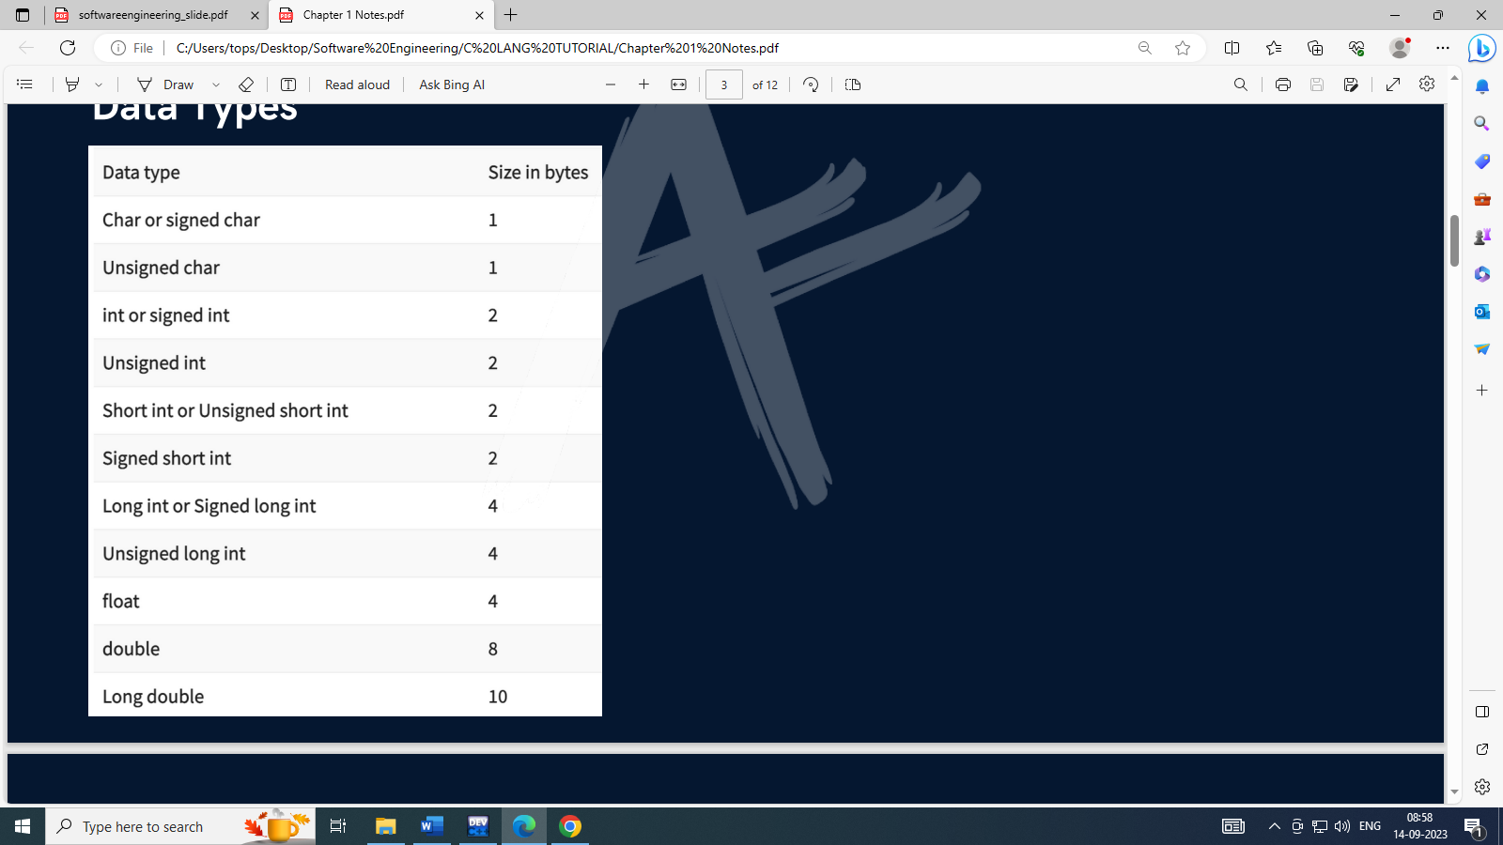

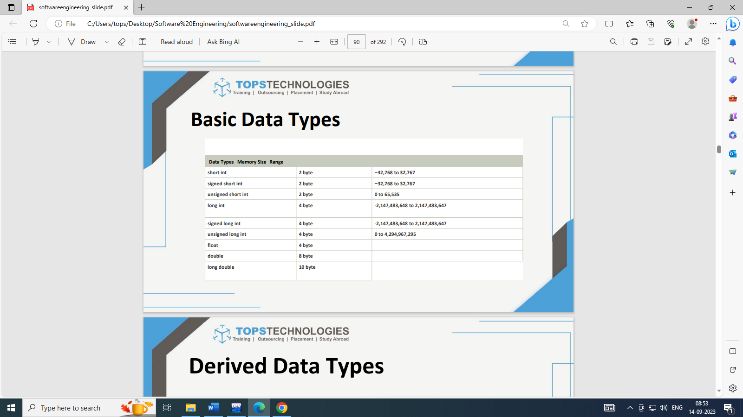

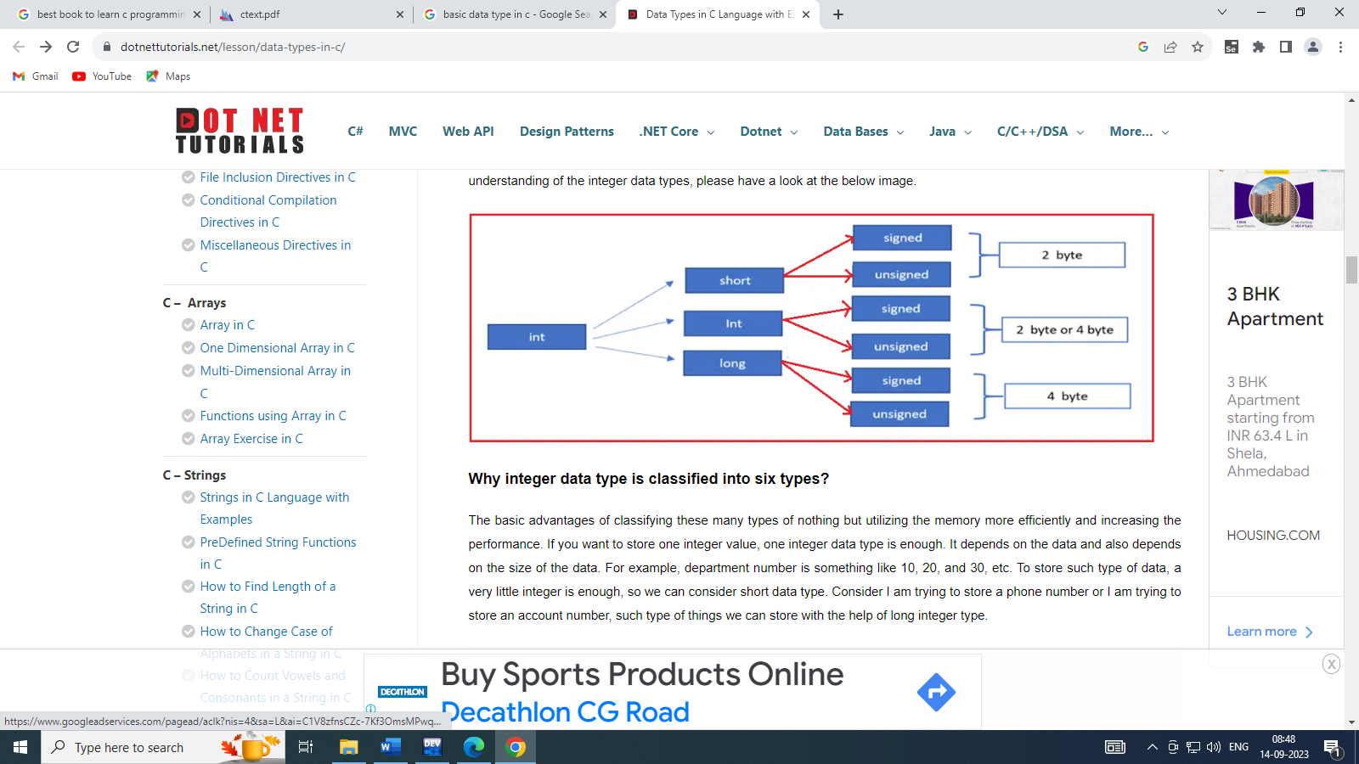

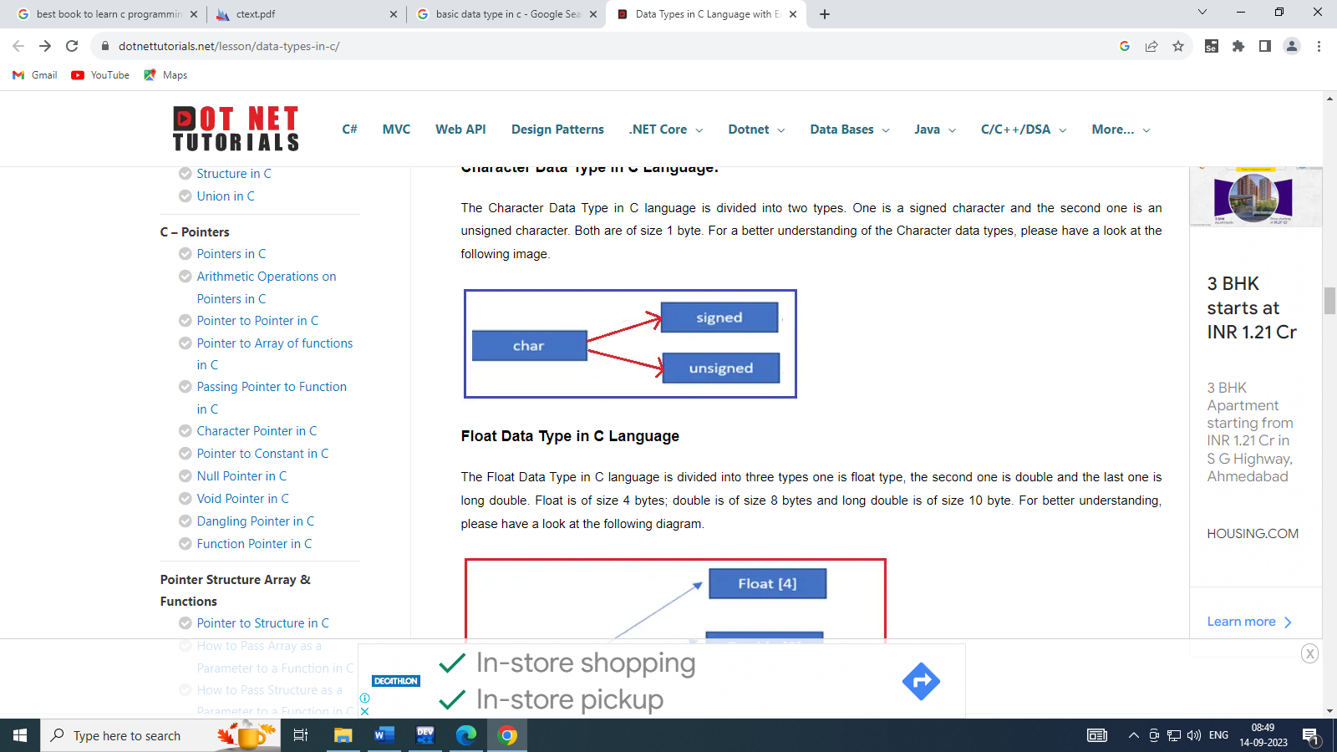

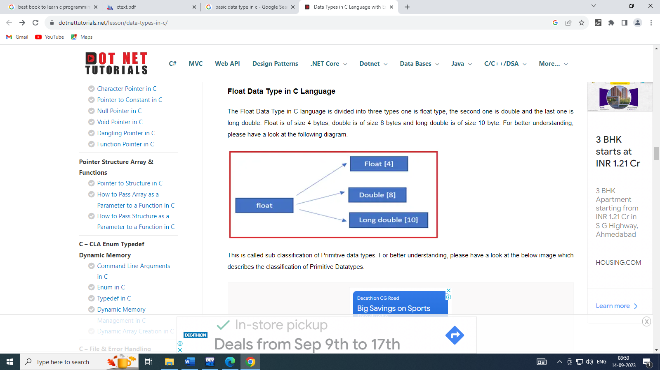

**-What is Constant**

Values that don't change(fixed)

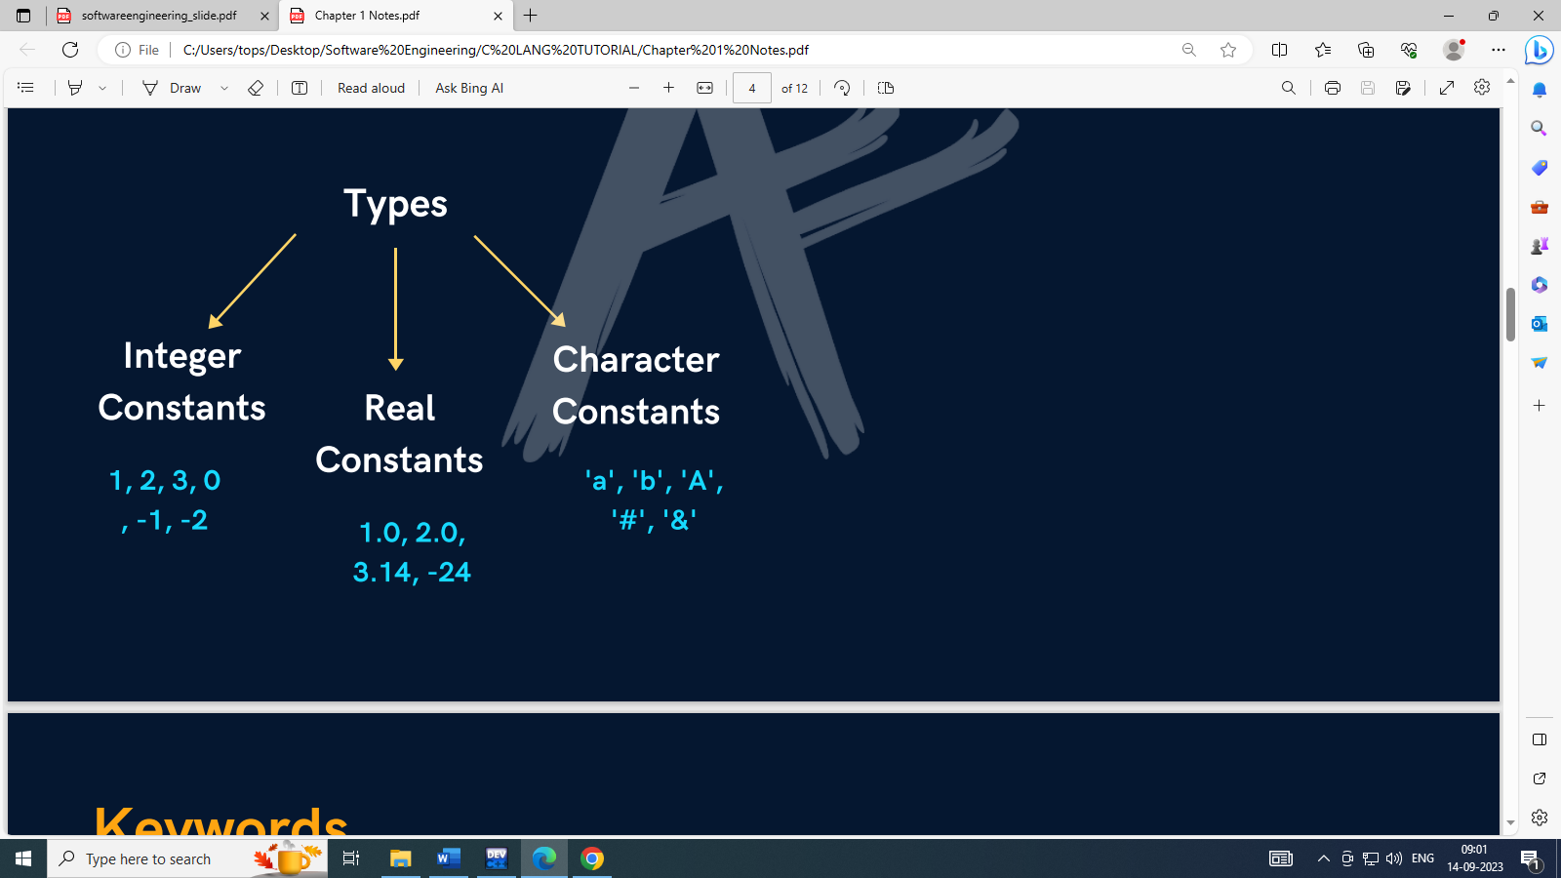

**-Keywords**

Reserved words that have special meaning to the compiler. 32 keywords in C.

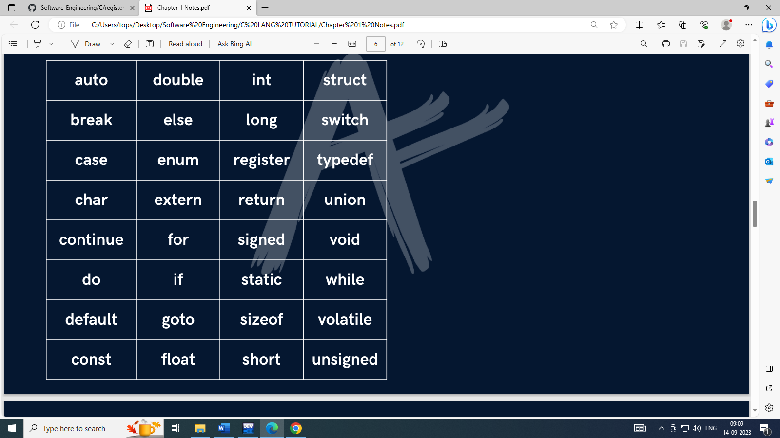

**-Operators**

A symbol that takes one or more operands such as variables, expressions or values and operates on them to give an output.

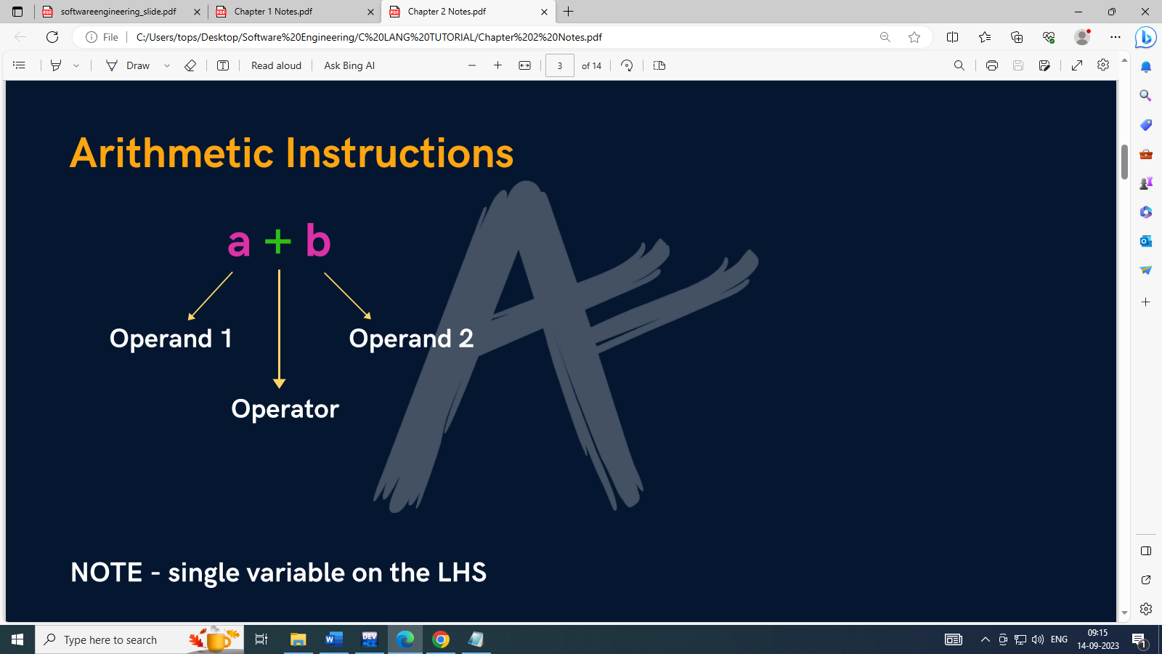

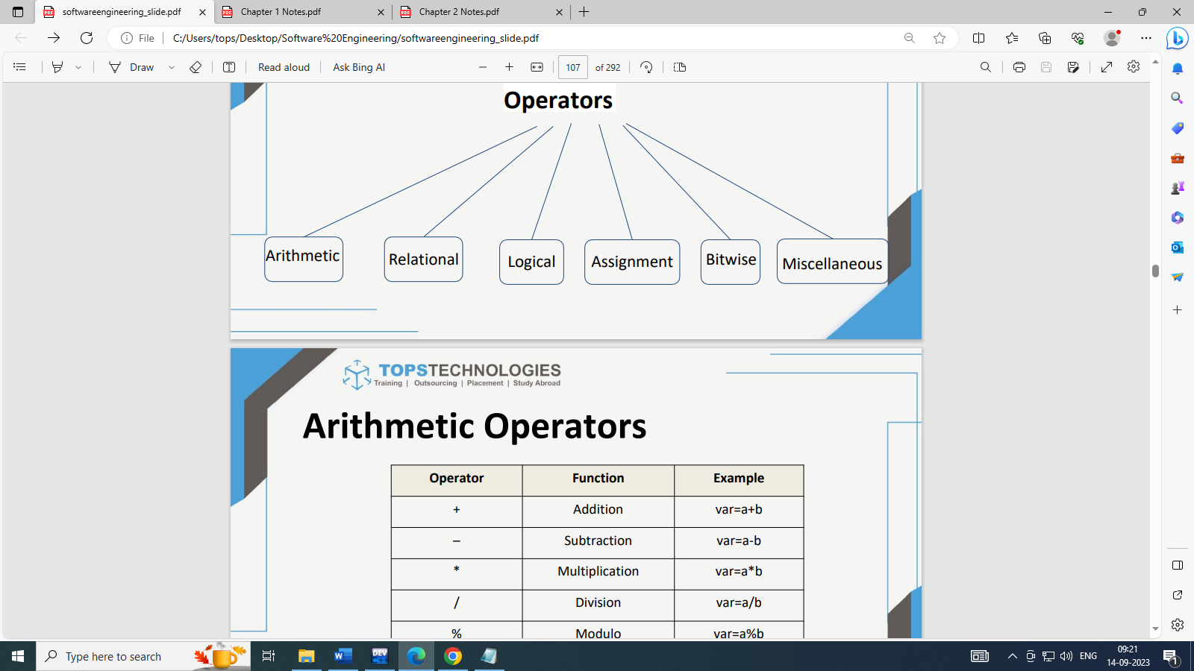

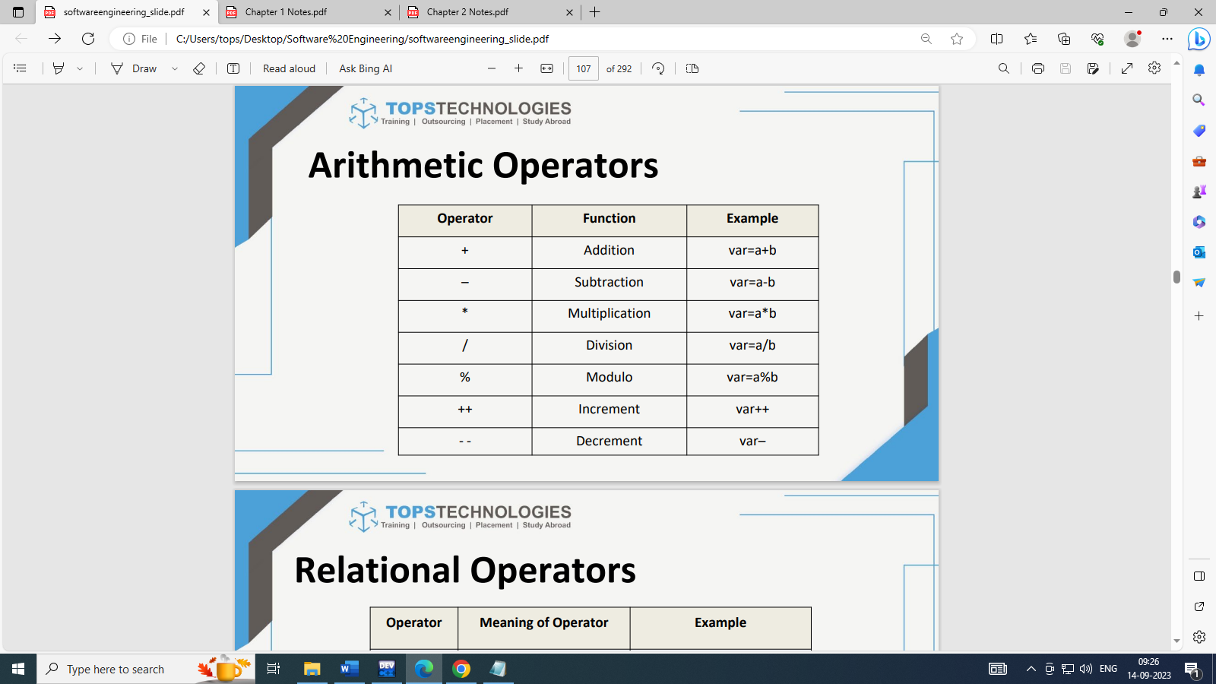

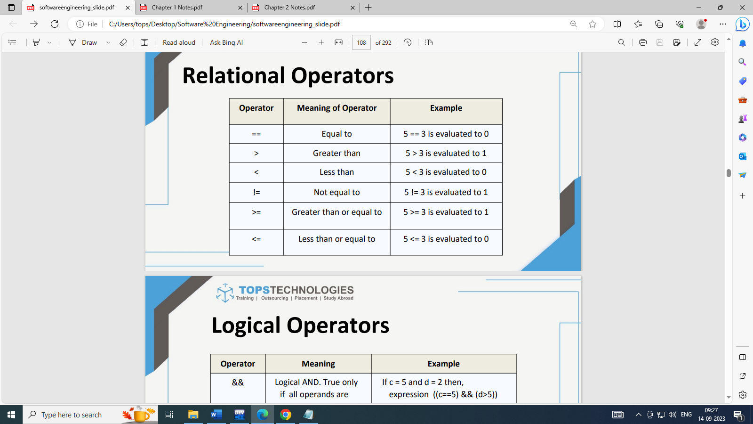

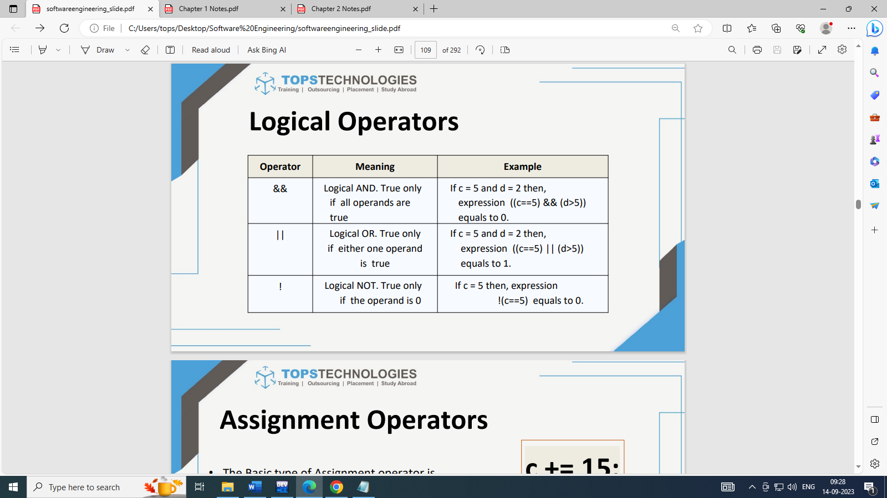

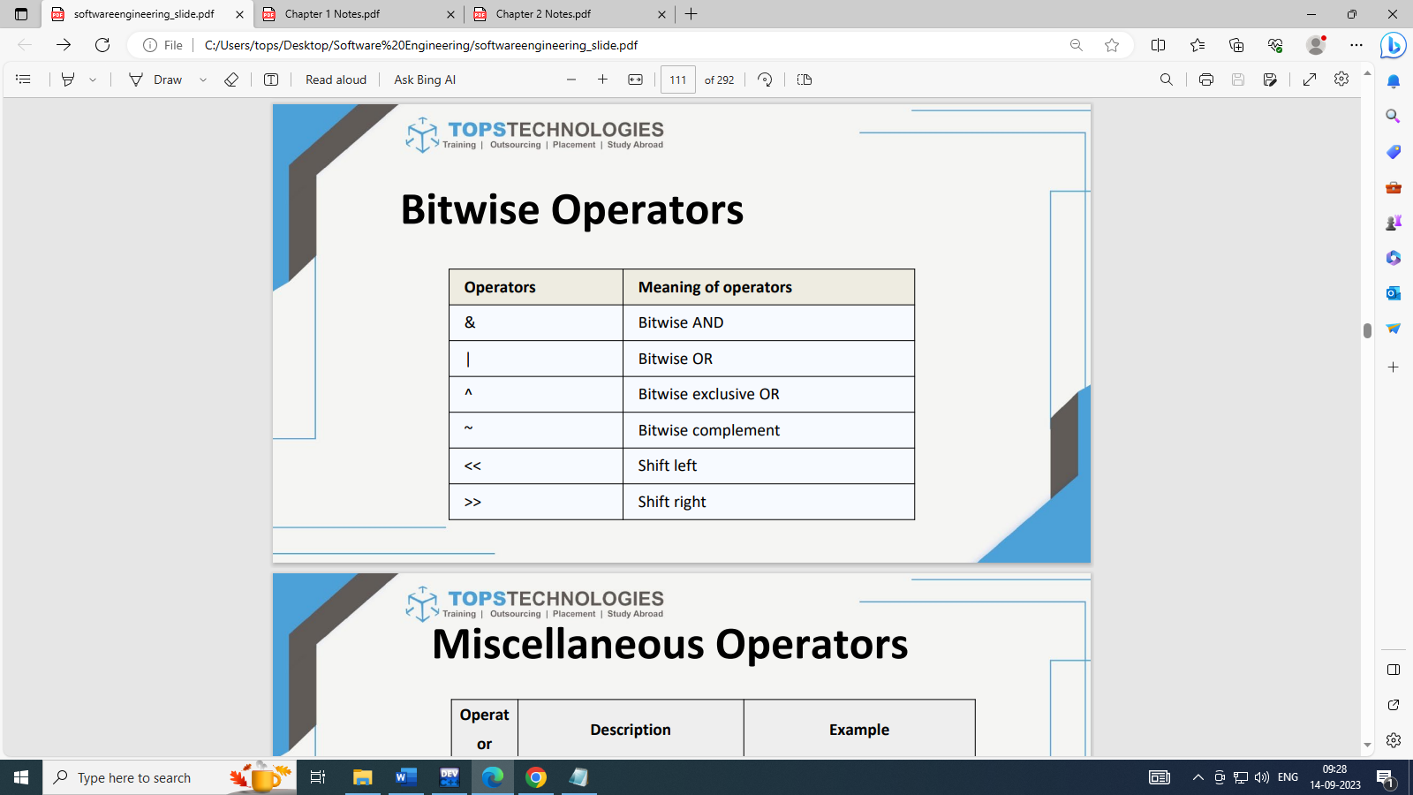

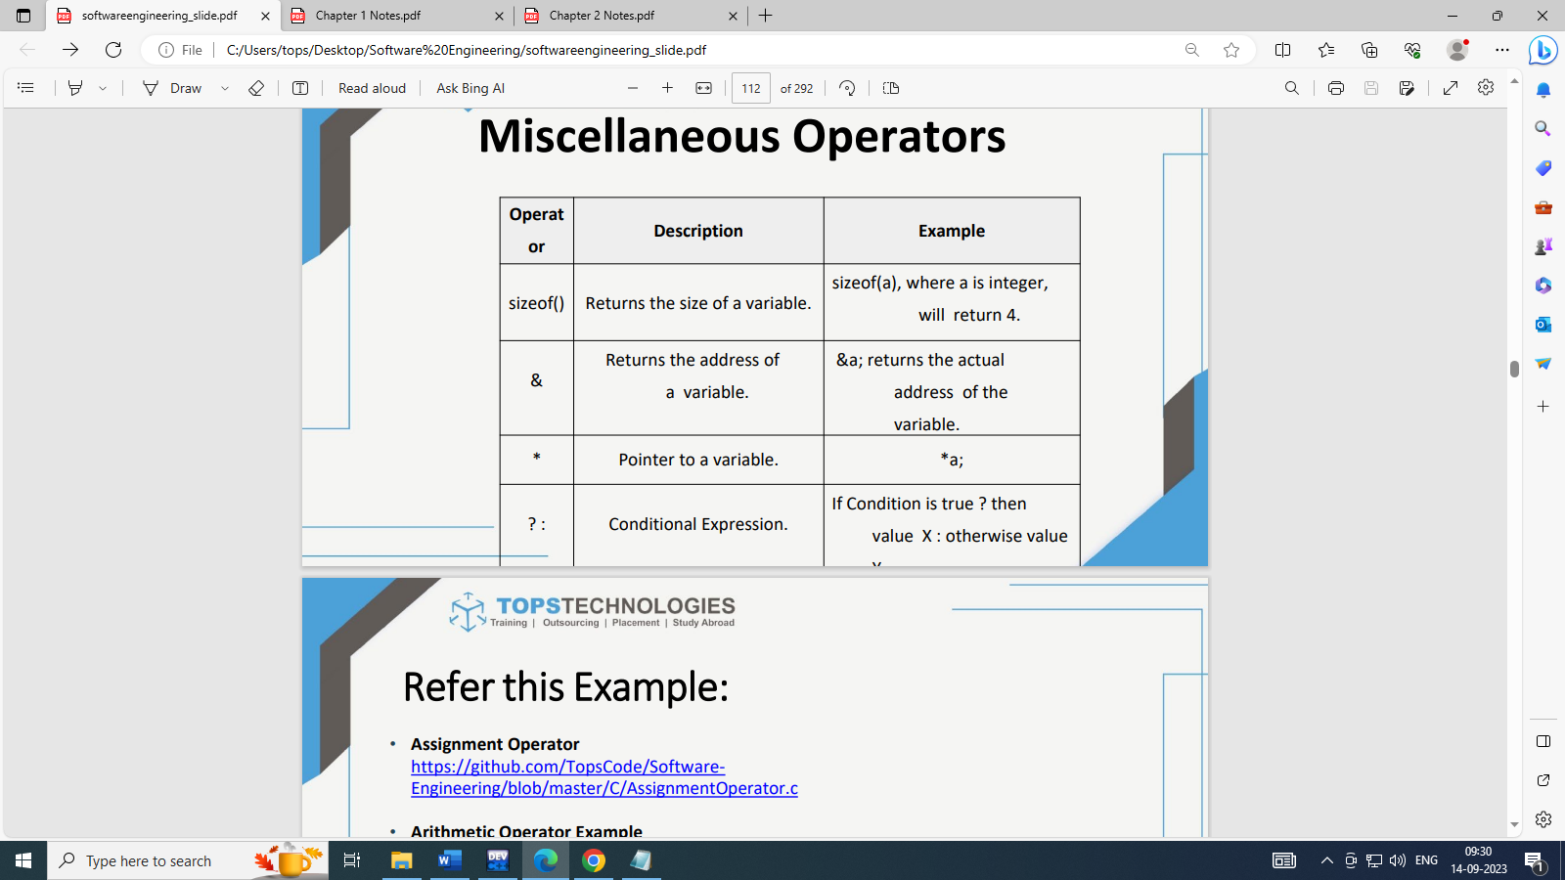

**-Different types of conditional statements :**

1).Simple if statement (without using else statement)

2).if .. else statement

3)..Nested if.. else statement

4).else if ladder

**1).Simple if statement (without using else statement)**

if (condition)

{

statements;

... ... ...

}

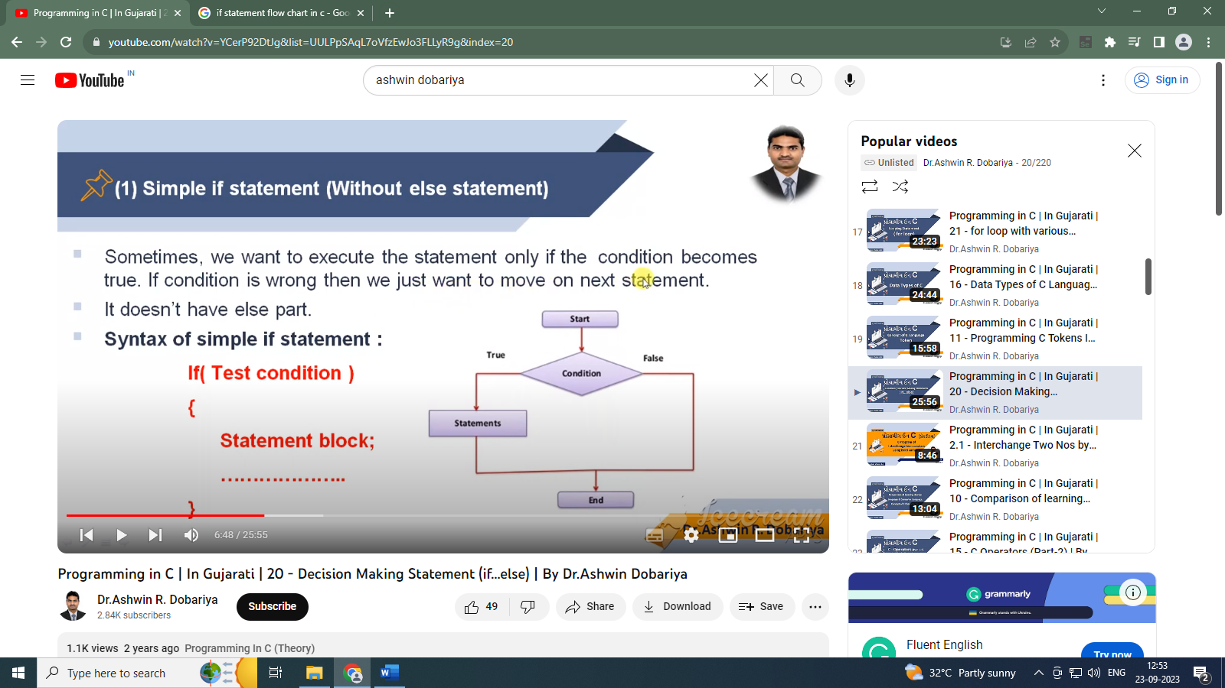

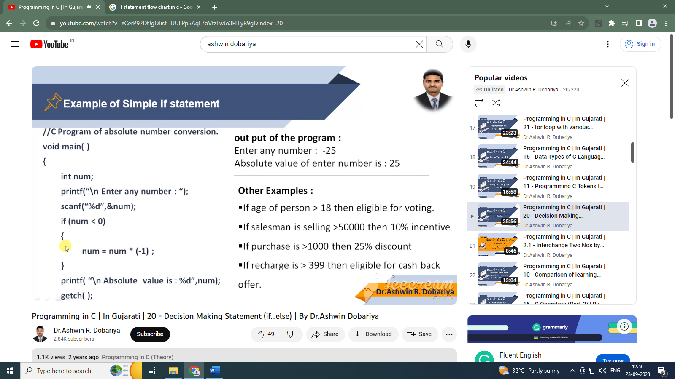

**2).if .. else statement**

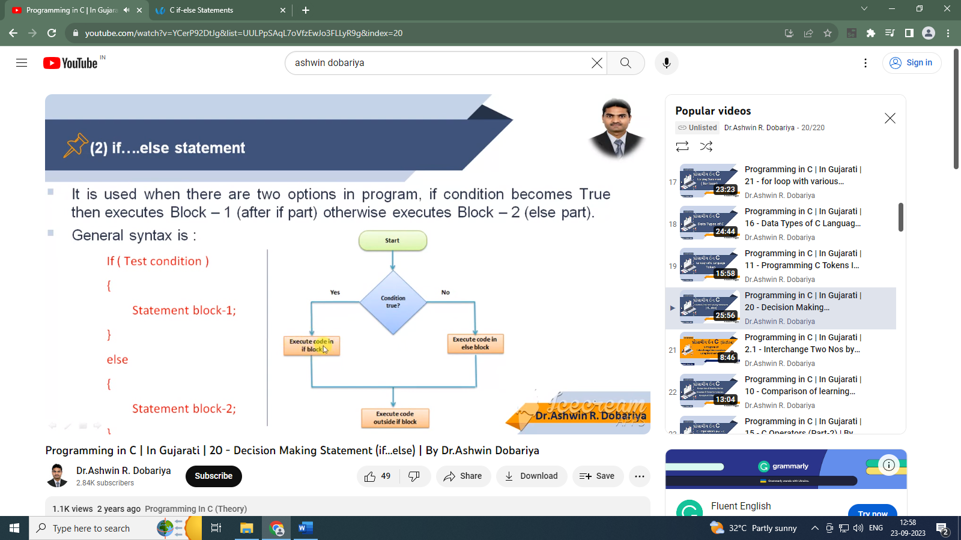

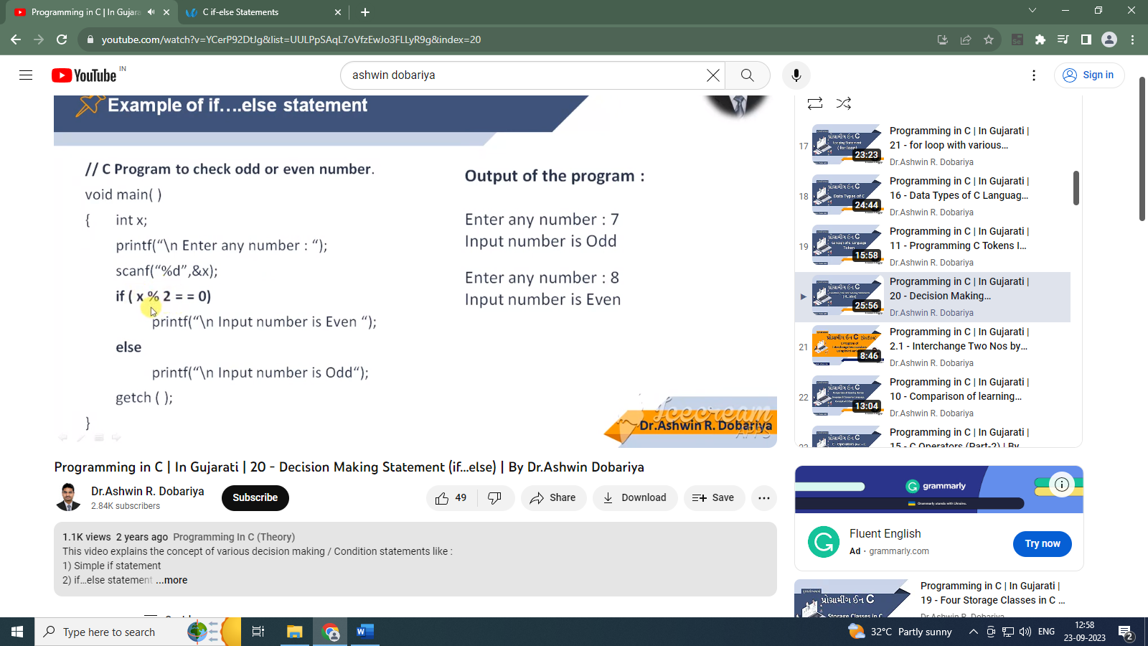

**3)..Nested if.. else statement**

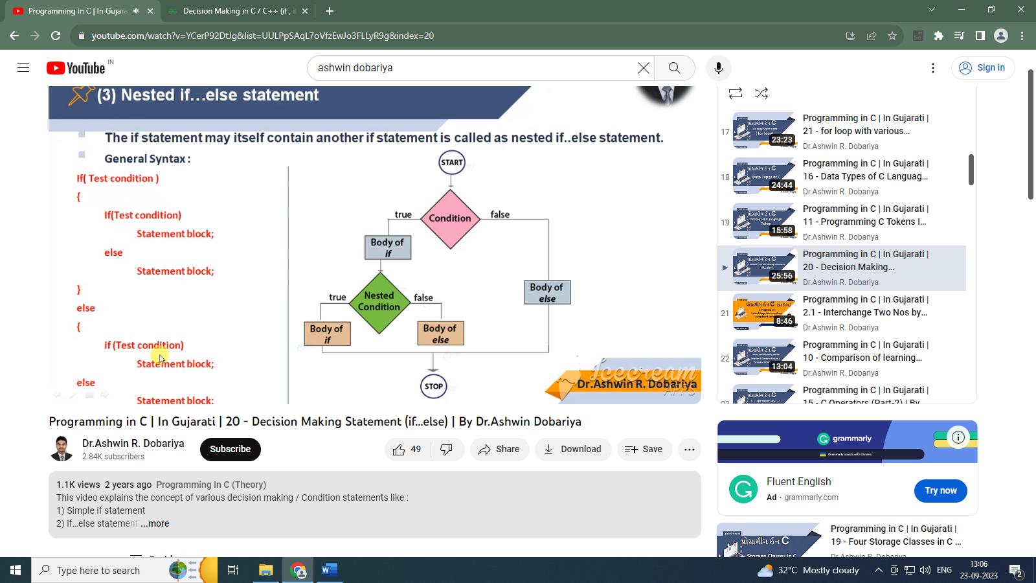

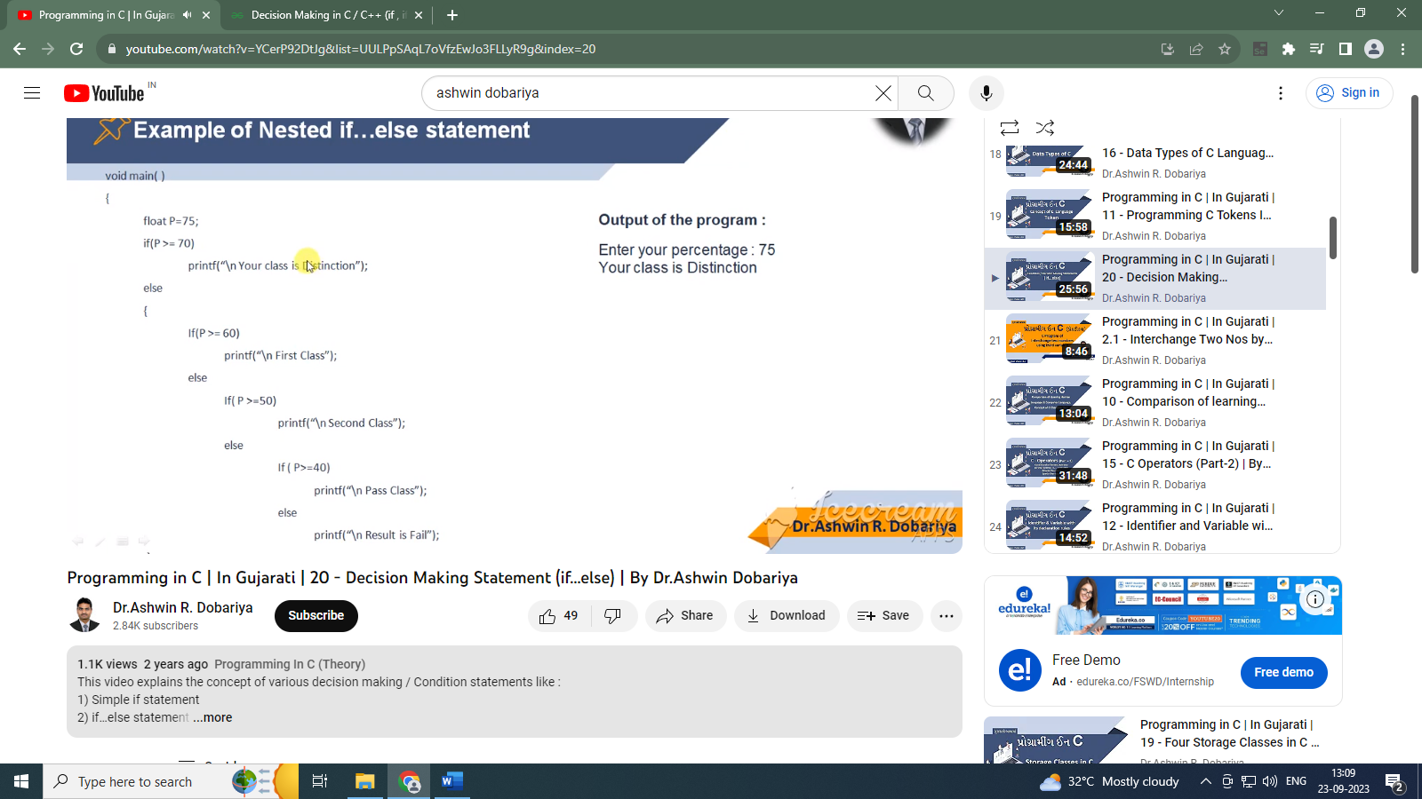

**4).else if ladder**

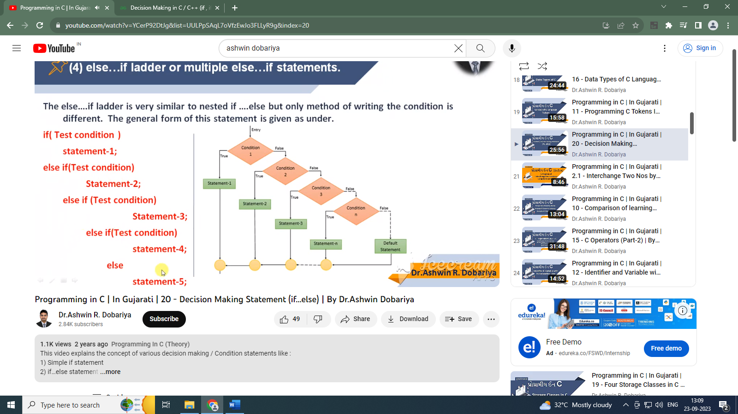

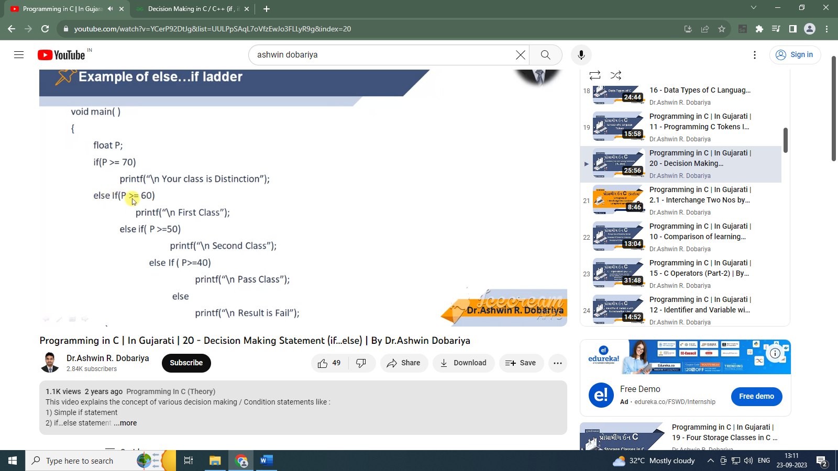

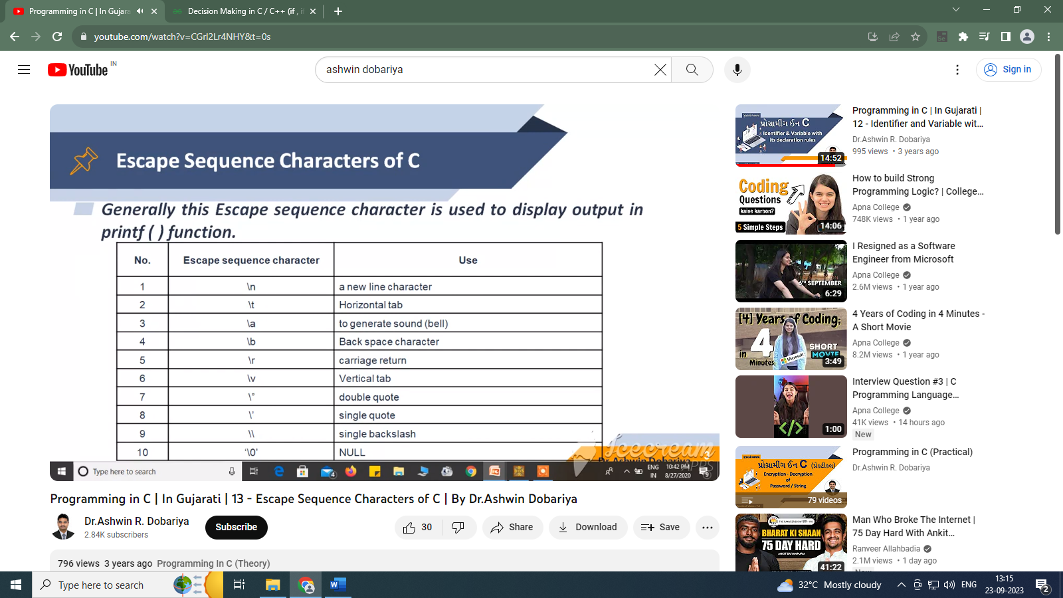

Ternery op

Condition?true:false